High End Home with Views! - Placerville

Property Details:
3 bed 4 bath 3900 sqft Lot size 3 acres Yr built 1996 HOA fees: $134

Work needed:
Flooring
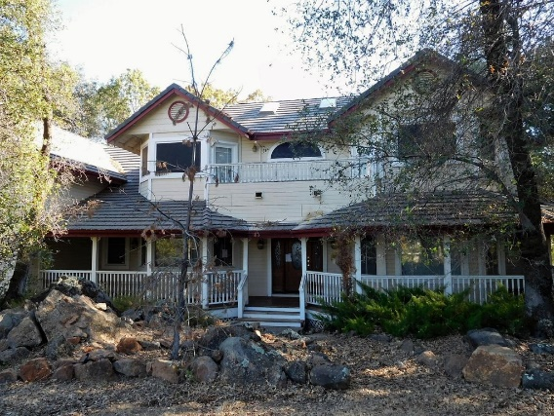
Partial Kitchen Remodel
Deck Work
Tree Trimming/Removal
Interior and Exterior Paint
Miscellaneous

Features:
Amazing Hillside Views
Gated Community
Large Front Deck and Rear Balcony
Granite Counter Tops
Completed Master Bathroom
Wet Bar
Large 3 Car Garage

Purchase: $610,000
Est. Rehab: $70,000
Est. ARV $899,000

Gross Profit: $219K
ROI: 32%
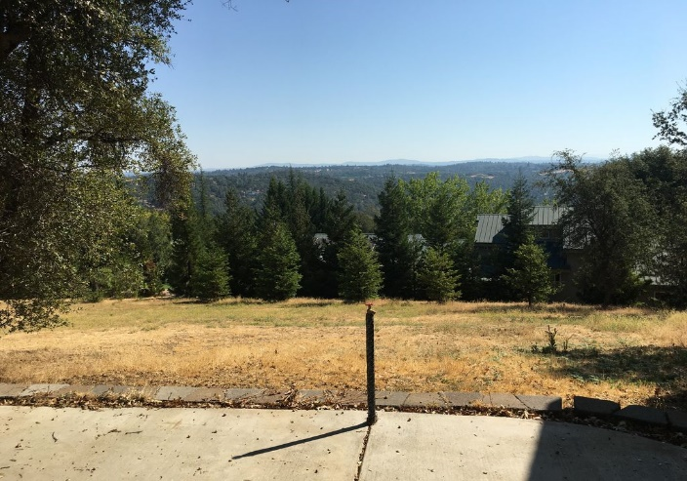
Please subtract your own financing and selling costs.

ARV Explanation: Avg Price per sf on CMA = $231.54
x 3900sf = $903,006

Link below includes:
Pictures
CMA
Map of comps

http://tinyurl.com/highendplacervilleflip

For address and more info contact Sam at (916) 367-8903

Please do your own due diligence on rehab cost, ARV, and profit.

Kelly Krezek
(916) 741-0717
Real World Properties
Kelly@RealWorldProperties.net
New Vision Realty Group
BRE# 01978410

To be the first to hear about great deals, Join Our VIP Buyers List at www.realworldproperties.net

